St Andrew's Church

Orford with Longford
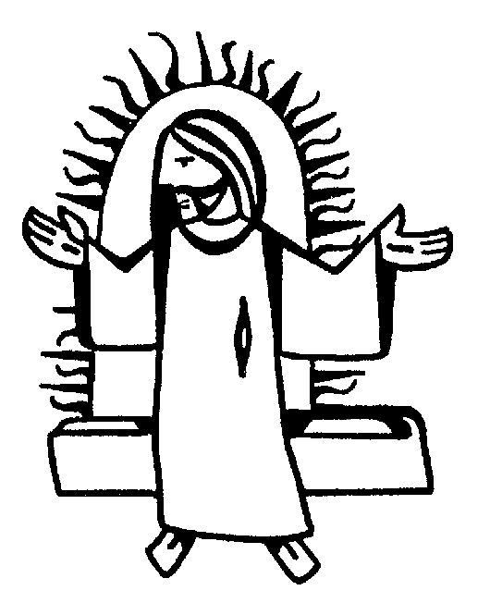

THE FUNERAL SERVICE

for

Audrey Forster

14th July 2008

Jesus said, “I am the resurrection and I am the life; those who believe in me, though they die, yet shall they live, and whoever lives and believes in me shall never die.”

Audrey Forster
Reception into Church
Sunday 13th July 2008

The priest leads the procession into church, reading the sentences from scripture.

Introduction and opening words

Priest: In the name of the Father, and of the Son, and of the Holy Spirit. Amen

We receive the body of our sister Audrey with confidence in God, the giver of life, who raised our Lord Jesus from the dead.

Sprinkling the coffin with water.

The coffin is sprinkled with holy water taken from the font. It is a reminder of baptism and the promise of eternal life that flows from it.

Priest: With this water we call to mind Audrey’s baptism. As Christ went through the deep waters of death for us, so may he bring us to the fullness of resurrection life with Audrey and all the redeemed.

The Paschal Candle is lit to remind us of our Lord’s victory over the power of death.

Priest: Jesus Christ is the light of the world
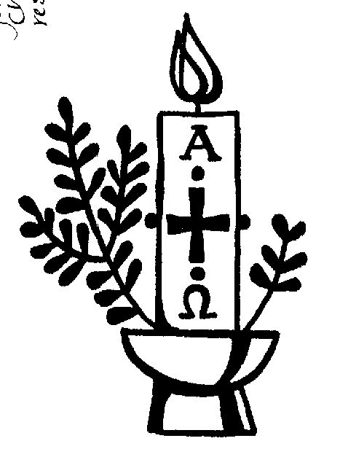
All: a light no darkness can quench

Priest: Stay with us, Lord, for it is evening:
All: and the day is almost over

Priest: Even the darkness is not dark for you:
All: and the night shines like day

Priest: Let your light scatter the darkness:
All: and fill your church with your glory

A reading from the letter to the Romans (verses from chapter 8)

I consider that our present sufferings are not worth comparing with the glory that will be revealed in us. If God is for us, who can be against us? He who did not spare his own Son, but gave him up for us all - how will he not also, along with him, graciously give us all things? Who will bring any charge against those whom God has chosen? It is God who justifies. Who is he that condemns? Christ Jesus, who died - more than that, who was raised to life - is at the right hand of God and is also interceding for us. Who shall separate us from the love of Christ? Shall trouble or hardship or persecution or famine or nakedness or danger or sword? No, in all these things we are more than conquerors through him who loved us. For I am convinced that neither death nor life, neither angels nor principalities nor powers, neither the present nor the future, neither height nor depth, nor anything else in all creation, will be able to separate us from the love of God that is in Christ Jesus our Lord.

This is the word of the Lord
All: Thanks be to God

Verses from Psalm 27

All say together:
1. The Lord is my light and my salvation
whom then shall I fear?
the Lord is the stronghold of my life
of whom shall I be afraid?

4. One thing I have asked from the Lord which I will require
that I may dwell in the house of the Lord
all the days of my life

5. to see the fair beauty of the Lord:
and to seek his will in the temple.

6. For he will hide me under his shelter in the day of trouble
and conceal me in the shadow of his tent
and set me high upon a rock.

8. And I will offer sacrifices in his sanctuary with exultation:
I will sing, I will sing praises to the Lord.

Glory to the Father and to the Son:
and to the Holy Spirit:
As it was in the beginning is now:
and shall be for ever. Amen

The Prayers

Priest: Let us pray:

Prayers for Audrey, her family and friends follow.

The Lord’s Prayer:

Priest: Let us pray for the coming of the Kingdom in the words our Saviour gave us:
All: Our Father, who art in heaven,
hallowed be thy name,
Thy kingdom come, thy will be done,
on earth, as it is in heaven.
Give us this day our daily bread,
and forgive us our trespasses,
as we forgive those who trespass against us.
And lead us not into temptation,
but deliver us from evil.

For thine is the kingdom,
the power and the glory,
for ever and ever. Amen.

A pall is spread over the coffin as John Rutter’s Pie Jesu, will be played.

Priest: Let us pray:

We are already God’s children, but what we shall be has not yet been revealed. Yet we know that when Christ appears we shall be like him, for we shall see him as he is.

Keep watch, dear Lord, with those who work, or watch, or weep this night, and give your angels charge over those who sleep. Enfold in your loving arms our sister Audrey who now rests in your eternal peace, and give her rest, this night and always. Amen

Rest eternal grant unto her O Lord
All: And let light perpetual shine upon her. Amen

Priest: May Christ, who out of defeat
brings new hope and a new future,
fill you with his light, his love and his new life;
and the blessing of God almighty
the Father, the Son and the Holy Spirit,
be with you tonight and always. Amen

A Gaelic blessing is played. Please feel free to listen or to leave as you wish.

St Andrew's Church

Orford with Longford

THE REQUIEM

for

Audrey Forster

14th July 2008

Jesus said, “I am the resurrection and I am the life; those who believe in me, though they die, yet shall they live, and whoever lives and believes in me shall never die.”

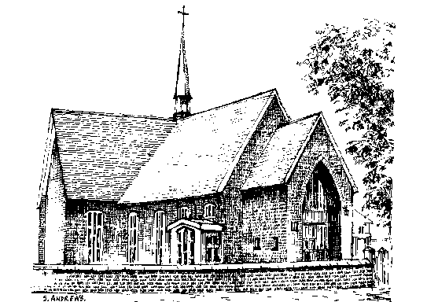The Requiem

Monday 14th July 2008

THE GATHERING

Introit Hymn: Dear Lord and Father of mankind,
(please stand) forgive our foolish ways;
re-clothe us in our rightful mind,
in purer lives thy service find,
in deeper reverence praise,
in deeper reverence praise.

In simple trust like theirs who heard,
beside the Syrian sea;
the gracious calling of the Lord,
let us, like them, without a word
rise up and follow thee,
rise up and follow thee.

O Sabbath rest by Galilee!
O calm of hills above,
where Jesus knelt to share with thee
the silence of the eternity,
interpreted by love,
interpreted by love!

Drop thy still dews of quietness,
till all our strivings cease;
take from our souls the strain and stress,
and let our ordered lives confess
the beauty of thy peace,
the beauty of thy peace.
Breathe through the heats of our desire
thy coolness and thy balm;
let sense be dumb, let flesh retire;
speak through the earthquake, wind and fire,
O still small voice of clam,
O still small voice of calm.

Priest: God so loved the world that he gave his only Son, so that everyone who believes in him may not perish but may have eternal life.

We meet in the name of Jesus Christ, who died and was raised to the glory of God the Father. Grace and mercy be with you
All: and also with you.

We have come here today to remember before God our sister Audrey; to give thanks for her life; to commend her to God our merciful redeemer and judge; to commit her body to be buried, and to comfort one another in our grief.

Priest: Let us pray (please remain standing):

Almighty God, you judge us with infinite mercy and justice and love everything you have made. In your mercy turn the darkness of death into the dawn of new life, and the sorrow of parting into the joy of heaven; through our Saviour, Jesus Christ. Amen

Prayers of Penitence

Priest: As children of a loving heavenly Father, let us ask his forgiveness, for he is gentle and full of compassion.

(After a period of silent reflection)
All: Most merciful God, Father of our Lord Jesus Christ, we confess that we have sinned in thought, word and deed. We have not loved you with our whole heart. We have not loved our neighbours as ourselves. In your mercy forgive what we have been, help us to amend what we are, and direct what we shall be; that we may do justly, love mercy, and walk humbly with you, our God. Amen

Priest: Almighty God, who forgives all who truly repent, have mercy upon you, pardon and deliver you from all your sins, confirm and strengthen you in all goodness, and keep you in life eternal; through Jesus Christ our Lord. Amen.
Collect:
Merciful Father, hear our prayers and comfort us; renew our trust in your Son, whom you raised from the dead; strengthen our faith that Audrey and all who have died in the love of Christ will share in his resurrection; who lives and reigns with you, in the unity of the Holy Spirit, one God, now and for ever. Amen

THE LITURGY OF THE WORD

Please sit for
A reading from the first letter of St Peter (1 Peter 1. 3-9)

At the end of the reading
Reader: This is the word of the Lord
All: Thanks be to God

Gradual hymn: (please stand)

O love that wilt not let me go,
I rest my weary soul in Thee:
I give Thee back the life I owe,
That in Thine ocean depths its flow
May richer, fuller be.

O Light that followest all my way,
I yield my flick'ring torch to Thee:
My heart restores its borrow'd ray,
That in Thy sunshine's blaze its day
May brighter, fairer be.

O Joy that seekest me through pain,
I cannot close my heart to Thee;
I trace the rainbow through the rain,
And feel the promise is not vain
That morn shall tearless be.

O Cross that liftest up my head,
I dare not ask to fly from Thee:
I lay in dust life's glory dead,
And from the ground there blossoms red
Life that shall endless be.

THE GOSPEL (please remain standing and face the reader)

Priest: Alleluia, alleluia.
God so loved the world that he gave his only Son.
All: Alleluia.

Hear the Gospel of our Lord Jesus Christ according to St John (John 6. 35-40)
All: Glory to you, O Lord

At the end
Priest: This is the Gospel of the Lord
All: Praise to you, O Christ

The Address

The Prayers

Priest: Let us pray

Leader: God of mercy, Lord of life, you have made us in your image to reflect your truth and light: we give you thanks for Audrey, for the grace and mercy she received from you, for all that was good in her life, and for the memories we treasure today. Especially we thank you for …

Leader: Lord in your mercy
All: hear our prayer.

Leader: Heavenly Father, you promised eternal life to those who believe. Remember for good this your servant Audrey as we also remember her. Here our prayers for all who have died, including Billy. Bring all who rest in Christ into the fullness of your kingdom where sins have been forgiven and death is no more.

Leader: Lord in your mercy
All: hear our prayer.

Leader: Loving Father, your mighty power brings joy out of grief and life out of death. Look in mercy on Eric, Marion, Warren and Nicola, and on all who mourn. Give them patient faith in times of darkness. Strengthen them with the knowledge of your love.

Leader: Lord in your mercy,
All: hear our prayer.
Leader: Compassionate Father, you are tender towards your children and your mercy is over all your works. Heal the memories of hurt and failure. Give us the wisdom and grace to use aright the time that is left to us here on earth, to turn to Christ and follow in his steps in the way that leads to everlasting life.

Leader: Lord in your mercy,
All: hear our prayer.

All: God of mercy, entrusting into your hands all that you have made
and rejoicing in our communion with all your faithful people,
we make our prayers through Jesus Christ our Saviour. Amen.

THE LITURGY OF THE SACRAMENT

The Peace (please stand)

Priest: Jesus says: Peace I leave with you; my peace I give to you. Not as the world gives do I give you. Do not let your hearts be troubled, neither let them be afraid. Alleluia.
The peace of the risen Lord be always with you
All: and also with you.

Priest: Let us offer one another a sign of peace.

Offertory Hymn:

Be still, my soul: the Lord is at your side;
bear patiently the cross of grief and pain;
leave to your God to order and provide;
in every change he faithful will remain.
Be still, my soul: your best, your heavenly friend
through thorny ways leads to a joyful end.

Be still, my soul: your God will undertake
to guide the future as he has the past.
Your hope, your confidence let nothing shake,
all now mysterious shall be clear at last.
Be still, my soul: the tempests still obey
his voice, who ruled them once on Galilee.
Be still, my soul: the hour is hastening on
when we shall be for ever with the Lord,
when disappointment, grief and fear are gone,
sorrow forgotten, love's pure joy restored.
Be still, my soul: when change and tears are past,
all safe and blessed we shall meet at last.

EUCHARISTIC PRAYER E (please kneel)

Priest: The Lord is here.
All: His Spirit is with us.

Priest: Lift up your hearts.
All: We lift them to the Lord.

Priest: Let us give thanks to the Lord our God.
All: It is right to give thanks and praise.

Priest: Blessed are you, gracious God, creator of heaven and earth, giver of life, and conqueror of death. By his death on the cross, your Son Jesus Christ offered the one true sacrifice for sin, breaking the power of evil and putting death to flight. With all your saints
All: we give you thanks and praise.

Priest: Through his resurrection from the dead you have given us new birth into a living hope, into an inheritance which is imperishable, undefiled, and unfading. With all your saints
All: we give you thanks and praise.

Priest: The joy of resurrection fills the universe, and so we join with angels and archangels, with Audrey and all your faithful people, evermore praising you and saying:

All: Holy, holy, holy Lord, God of power and might, heaven and earth are full of your glory. Hosanna in the highest. Blessed is he who comes in the name of the Lord. Hosanna in the highest.

Priest: We praise and bless you, loving Father, through Jesus Christ, our Lord; and as we obey his command, send your Holy Spirit, that broken bread and wine outpoured may be for us the body and blood of your dear Son.

On the night before he died he had supper with his friends and, taking bread, he praised you. He broke the bread, gave it to them and said: Take, eat; this is my body which is given for you; do this in remembrance of me.
When supper was ended he took the cup of wine. Again he praised you, gave it to them and said: Drink this, all of you; this is my blood of the new covenant, which is shed for you and for many for the forgiveness of sins. Do this, as often as you drink it, in remembrance of me.

So, Father, we remember all that Jesus did, in him we plead with confidence his sacrifice made once for all upon the cross. Bringing before you the bread of life and cup of salvation, we proclaim his death and resurrection until he comes in glory.

Priest: Praise to you, Lord Jesus:
All: Dying you destroyed our death, rising you restored our life:
Lord Jesus, come in glory.

Priest: Lord of all life, help us to work together for that day when your kingdom comes and justice and mercy will be seen in all the earth. Look with favour on your people, gather us in your loving arms and bring us with St Andrew and all the saints to feast at your table in heaven. Through Christ, and with Christ, and in Christ, in the unity of the Holy Spirit, all honour and glory are yours, O loving Father, for ever and ever.
All: Amen.

Priest: Let us pray with confidence as our Saviour taught us
All: Our Father, who art in heaven, hallowed be thy name; thy kingdom come; thy will be done; on earth as it is in heaven. Give us this day our daily bread. And forgive us our trespasses, as we forgive those who trespass against us. And lead us not into temptation; but deliver us from evil. For thine is the kingdom, the power and the glory, for ever and ever. Amen.

Priest: Every time we eat this bread and drink this cup,
All: we proclaim the Lord’s death until he comes.

All: Lamb of God, you take away the sin of the world, have mercy on us.
Lamb of God, you take away the sin of the world, have mercy on us.
Lamb of God, you take away the sin of the world, grant us peace.

Priest: Jesus is the Lamb of God who takes away the sin of the world.
Happy are those who are called to his supper.
All: Lord, I am not worthy to receive you, but only say the word and I shall be healed.

Holy Communion is administered at the front of Church. Everyone is warmly invited to receive Holy Communion at this Eucharist. Those who prefer to receive a blessing are also invited to come forward at the same time.

Hymn during Communion:

Make me a channel of your peace.
Where there is hatred let me bring your love.
where there is injury, your pardon, Lord,
and where there's doubt, true faith in you.

Oh Master, grant that I may never seek
so much to be consoled as to console,
to be understood, as to understand,
to be loved, as to love with all my soul.

Make me a channel of your peace.
Where there's despair in life, let me bring hope.
Where there is darkness, only light,
and where there's sadness, ever joy.

Oh Master, grant that I may never seek
so much to be consoled as to console,
to be understood, as to understand,
to be loved, as to love with all my soul.

Make me a channel of your peace.
It is in pardoning that we are pardoned,
in giving of ourselves that we receive,
and in dying that we're born to eternal life.

Prayer After Communion:

Priest: Gracious God, we thank you that in your great love you have fed us with the spiritual food and drink of the body and blood of your Son Jesus Christ and have given us a foretaste of your heavenly banquet: grant that this sacrament may be to us a comfort in affliction and a pledge of our inheritance in that kingdom where there is no death, neither sorrow nor crying, but fullness of joy with all your saints; through Jesus Christ our Saviour. Amen

All: Heavenly Father, in your Son Jesus Christ you have given us a true faith and a sure hope. Strengthen this faith and hope in us all our days that we may live as those who believe in the communion of saints, the forgiveness of sins and the resurrection to eternal life; through Jesus Christ our Lord. Amen.

Hymn: (during which the pall is removed)

Guide me, O thou great Redeemer,
pilgrim through this barren land;
I am weak, but thou art mighty;
hold me with thy powerful hand:
bread of heaven,
feed me now and evermore.

Open now the crystal fountain
whence the healing stream doth flow;
let the fiery cloudy pillar
lead me all my journey through;
strong deliverer,
be thou still my strength and shield.

When I tread the verge of Jordan,
bid my anxious fears subside;
death of death, and hells destruction,
land me safe on Canaan's side:
songs and praises
I will ever give to thee.

The Commendation

Priest: Let us commend Audrey to the mercy of God our maker and redeemer.

[Silence is kept]

Priest: God our creator and redeemer, by your power Christ conquered death and entered into glory. Confident of his victory and claiming his promises, we entrust Audrey to your mercy in the name of Jesus our Lord, who died and is alive and reigns with you, now and for ever. Amen

The Nunc Dimittis is read as the procession leaves the church.

Acknowledgement: Common Worship: Pastoral Services, material from which is included in this service, is copyright © The Archbishops’ Council (2000)

First (epistle) reading for the funeral of Audrey Forster

A reading from the first letter of St Peter

Praise be to the God and Father of our Lord Jesus Christ! In his great mercy he has given us new birth into a living hope through the resurrection of Jesus Christ from the dead, and into an inheritance that can never perish, spoil or fade - kept in heaven for you, who through faith are shielded by God's power until the coming of the salvation that is ready to be revealed in the last time.

In this you greatly rejoice, though now for a little while you may have had to suffer grief in all kinds of trials. These have come so that your faith - of greater worth than gold, which perishes even though refined by fire - may be proved genuine and may result in praise, glory and honor when Jesus Christ is revealed.

Though you have not seen him, you love him; and even though you do not see him now, you believe in him and are filled with an inexpressible and glorious joy, for you are receiving the goal of your faith, that is, the salvation of your soul.

Reader: This is the word of the Lord
All: Thanks be to God

Gospel reading for the funeral of Audrey Forster

Priest: Alleluia, alleluia.
God so loved the world that he gave his only Son.
All: Alleluia.

Hear the Gospel of our Lord Jesus Christ according to St John
All: Glory to you, O Lord

Then Jesus declared, "I am the bread of life. He who comes to me will never go hungry, and he who believes in me will never be thirsty. But as I told you, you have seen me and still you do not believe. All that the Father gives me will come to me, and whoever comes to me I will never drive away. For I have come down from heaven not to do my will but to do the will of him who sent me. And this is the will of him who sent me - that I shall lose none of all that he has given me, but raise them up at the last day. For my Father's will is that everyone who looks to the Son and believes in him shall have eternal life, and I will raise him up at the last day."

Priest: This is the Gospel of the Lord
All: Praise to you, O Christ

Prayers for use at the Reception of the Body into Church:

Blessed be the God and Father of our Lord Jesus Christ,
who has blessed us all with the gift of this earthly life
and has given to our sister Audrey
her span of years and gifts of character.
God our Father, we thank you now for all her life,
for every memory of love and joy,
for every good deed done by her
and every sorrow shared with us.
We thank you for her life and for her death,
we thank you for the rest in Christ she now enjoys,
we thank you for giving her to us,
and we thank you for the glory we shall share together.
We ask this in the name of Jesus Christ our Lord. Amen

Visit we pray Lord, this your family, and guard with your watchful tenderness the hearts which have been hallowed by your sacred mysteries; that as by your mercy we receive the healing grace of salvation, so by your power and protection we may ever retain them; through Jesus Christ our Lord. Amen

Almighty God, Father of all mercies and giver of all comfort: deal graciously we pray with those who mourn, that casting all their care on you, they may know the consolation of your love; through Jesus Christ our Saviour. Amen

